Anthony Cunningham

STAT 2010

10/20/2016

**Homework 8 SAS Code**

# 7: **data** ancient;

input nitrogen;

datalines;

63.4

65.0

64.4

63.3

54.8

64.5

60.8

49.1

51.0

;

**run**;

**proc** **univariate** plot data=ancient; *to check for skewness and outliers by looking at box plot;

var nitrogen;

**run**;

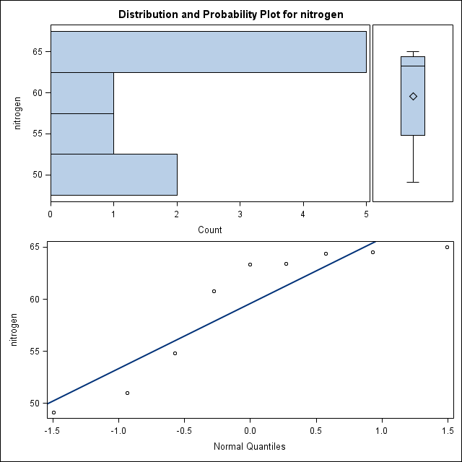

**proc** **means** n mean stddev clm alpha = **0.10**; *to find population mean;

var nitrogen;

**run**;

|  |  |  |  |  |
| --- | --- | --- | --- | --- |
| **Analysis Variable : nitrogen** | | | | |
| **N** | **Mean** | **Std Dev** | **Lower 90% CL for Mean** | **Upper 90% CL for Mean** |
| 9 | 59.5888889 | 6.2552867 | 55.7115535 | 63.4662242 |

# 10: **proc** **univariate** mu0=**78.1** data=ancient; *to do t-test and find p-value;

var nitrogen;

**run**;

|  |  |  |  |  |
| --- | --- | --- | --- | --- |
| **Tests for Location: Mu0=78.1** | | | | |
| **Test** | **Statistic** | | **p Value** | |
| **Student's t** | **t** | -8.87782 | **Pr > |t|** | <.0001 |

# 11: **data** brainresponse;

input tone call;

diff = call - tone;

datalines;

474 500

256 138

.

.

19 66

;

**run**;

**proc** **univariate** plot data=brainresponse; *to check for normalness and outliers, also to find t and p-value;

var diff;

**run**;

|  |  |  |  |  |
| --- | --- | --- | --- | --- |
| **Tests for Location: Mu0=0** | | | | |
| **Test** | **Statistic** | | **p Value** | |
| **Student's t** | **t** | 4.840153 | **Pr > |t|** | <.0001 |

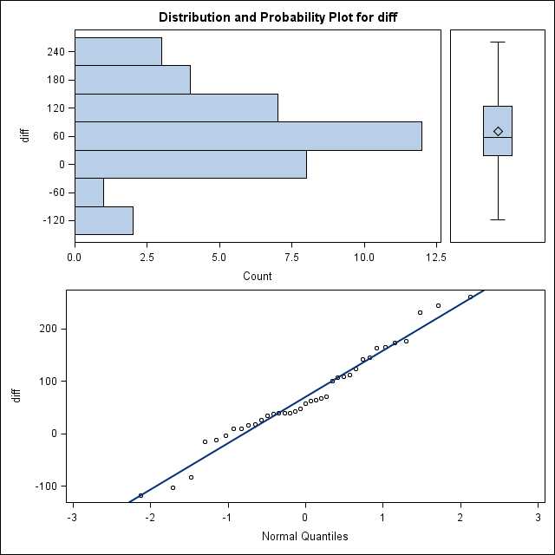

# 12: **proc** **means** data=brainresponse n mean stddev clm alpha=**.01**; *find population mean;

var diff;

**run**;

|  |  |  |  |  |
| --- | --- | --- | --- | --- |
| **Analysis Variable : diff** | | | | |
| **N** | **Mean** | **Std Dev** | **Lower 99% CL for Mean** | **Upper 99% CL for Mean** |
| 37 | 70.3783784 | 88.4465788 | 30.8356360 | 109.9211207 |
|  |  |  |  |  |